18511160023_EMETUCHE WINNER CHIDIUTO
School -------------------------------------- Class ₋₋₋₋₋₋₋₋₋₋ Name ----EMETUCHE WINER CHIDIUTO------- Student ID ₋₋₋₋₁₈₅₁₁₁₆₀₀₂₃₋₋₋₋₋₋₋₋

Final Examination Paper
Fall Semester
Subject of Examination | Web Application Development |  |  |  | Type of Test Paper |  | A
Test Type | Closed-book |  |  |  | Participants |  | 18SE
Title Number | I | II | III | IV |  |  |  |  | Total Points
Score

Attention:
(1) Exam time: 14:00 to 16:00, January 13, 2021, Beijing time. Please complete the questions on time.
(2) Send the mail to: jsj_wcw@wzu.edu.cn before:2021-01-13 18:00 Beijing time.
(3) The duplicate paper get zero score.

Print your name, student ID, the name of your class and the name of your school on the vertical lines left.
This examination has four parts, with a total of 41 questions. You must answer all questions in this examination. Write your answers in this booklet. All work should be written in pen.
Scrap paper is not permitted for any part of this examination, but you may use the blank spaces in this booklet as scrap paper. A perforated sheet of scrap graph paper is provided at the end of this booklet for any question for which graphing may be helpful but is not required. You may remove this sheet from this booklet. Any work done on this sheet of scrap graph paper will not be scored.
I. Directions: For each statement, fill with the words or expression that best completes the statement or answers the question. Write your answers directly in your test paper. Each correct answer will receive 2 credits. (20 credits in all, 1 for each)
Score

1. Three HTML tags are used to describe the overall structure of a web page.
The (1) <HTML> tag indicates that the file is in the HTML language.
The (2) <HEAD> tag specifies that the lines within the beginning and ending points of the tag are the prologue to the rest of the file.
The (3) <BODY> tag encloses the remainder of your HTML page (text, links, pictures, and so on).

2. Ordered and unordered lists use the <li> tag for list items.
Definition lists use the (4) dl and (5) dt tags for list items.

3. With the <ol> tag, the (6) start attribute is used to specify the starting value for the list. To change the numbering within a list, the (7) attribute is used.

4. There are three types of bullets that can be specified for unordered lists using the type attribute. The bullet types supported by the type attribute are (8) disc , (9) circle , and (10) square .

5. An (11) absolute path points to a page by starting at the top level of a directory hierarchy and working downward through all intervening directories to reach the file.

6. There are three ways to add CSS to HTML. CSS can be added to HTML by linking to a separate (12) stylesheet .css file , importing files from existing stylesheets, embedded CSS in a (13) html tag, or added(14) inline directly to HTML elements.

- Using the (15) font-size style attribute to decide the size of text in a page. It’s important to know there are two distinct kinds of units in CSS. The (16) absolute measurement attempt to describe a particular size, as in the real world. The (17)
- Relative measurement is about changes to some default value. Generally, web developers are moving toward relative measurement for font sizes.

8. You can bundle several lines of code into one container and give this new chunk of code a name: a (18) function . You can also take a whole bunch of variables, put them into a container, and give it a name. That’s called an (19) array . If you combine functions and data, you get another interesting structure called an (20) object .

II. Directions: For each statement or question, choose the word or expression that, of those given, best completes the statement or answers the question. Make your choice by writing the corresponding letter [A], [B], [C] or [D] in the answer table. (20 credits in all; 2 for each)
Score
1 | 2 | 3 | 4 | 5 | 6 | 7 | 8 | 9 | 10
A | B | C | D | B | A | A | B | C | C
(1) Just like HTML and CSS, which symbol indicates comments ( )?
A. // B. / C. /* t D. */

(2) Note the labels have a ( ) attribute which connects each label to the corresponding check box.
A. switch B. for C. name D. length

(3) With the css style:
p.A {font-weigh:bold;}
Which text will be printed in bold by ( )?
A. <a class="A">Text A</a> B. <a class="B">Text B</a>
C. <p class="A">Text C</p> D. <p class="B">Text D</p>

(4) The ( ) attribute of border can’t set the border properties.
A. border-color B. border-style
C. border-width D. border-background
(5) The result of 5+22/2%2 is ( )
A. 5 B. 6 C. 7 D. 8

(6). Unordered lists are often referred to as bulleted lists. ( ) is the tag of unordered lists.
A. <ul>…<li>…</ul> B. <ol>…<li>…</ol>
C. <hl>…<li>…</hl> D. < li >…< ol >…</ li >

(7) The ( ) is a special set of complex variables that encapsulates the entire contents of the web page.
A. DOM B. DTD C. CSS D. HTML

(8) Which of the following terms is a valid variable definition? ( )
A. _$te$t2 B. with C. a bc D.2a

(9) Can we place JavaScript code in one of the following HTML elements? ( )
A. <js> B. <scripting> C. <script> D.<body>

(10) How to output Hello World in the warning box? ( )
A. alertBox= “Hello world”; B. new alert(“Hello world”);
C. alert(“Hello world”); D. alertBox(“Hello world”);

III. Directions: Base your answers on the information of questions and on your knowledge of Web Application Development. Write the source code directly in your test paper. Each correct answer will receive 2 credits. (30 credits in all; 2 for each)
Score
1. Metadata is information about data. The <meta> tag provides metadata about the HTML document. Read the program and complete it according to the requirements.
<head>
<meta charset="UTF-8">
<meta http-equiv=”refresh” content=” 3”> // requirement (a)
<meta name="description" content="Free Web tutorials">
<meta name=" author " content=" 18511160023_EMETUCHE WINNER CHIDIUTO">// requirement (b)
<meta name=" paper_type " content="examination ">// requirement (c)
</head>
Requirements:
// (a). The web page will be auto-refreshed every 3 seconds.
// (b).The web page will be indexed by these key words and searched by engine.
// (c).This meta data shows the author of the web page

2. Function is simply a collection of code lines. Click button and call the function to change body’s style. Read the program and complete it.

<head>
<script type = "text/javascript">
function changeBackground () {
document.body.style.backgroundColor = "peachpuff";
}
</script>
</head>
<body>
<input type = "button" value = "peachpuff" onclick = " changeBackground() "/>
</body>

3. Arrays and for loops are natural companions. The for loop steps through each element of the array.
<script type = "text/javascript">

var gameList = [
"Flight Gear", "Sauerbraten", "Future Pinball", "Racer",
"TORCS","Orbiter","Step Mania", "NetHack", "Marathon", "Crimson Fields"
];
var text = "";
for (i = 0; i < gameList.length; i++){
text += "I love " + gameList[i] + "\n";
} // end for loop
alert(text);
</script>

4. A set of rules for describing how various objects will display. The page will display the page as yellow text on a red background. Completed the style rules.
(Tips: use background-color attribute to set the background color)
<head>
<style type = "text/css">
body {
(8) background-color:red;
(9) color:yellow;
}
</style>
</head>
<body>
Yellow text on a red background
</body>

5. To force the button onto its own line, set its clear attribute to both. This means that the button should have no elements to the left or the right. It should occupy a line all its own.
<head>
<style type = "text/css">
button {
float: left;
clear: both;
}
</style>
</head>
<body>
<button type = "button">submit request</button>
</body>

6. Objects have other characteristics besides properties. They can also have methods. A method is simply a function attached to an object.

<script type="text/javascript">
//create the critter
var critter = new Object();
//add some properties
critter.name= "Tom";
critter.age= 5;
//create a method
critter.talk = function() {
msg = "Hi! My name is " + this.name;
msg += " and I'm " + this.age;
alert(msg);
} // end method
// call the talk method
critter.talk();
</script>

IV. Directions: Base your answers on the information of questions and on your knowledge of WEB. Record your answers in the spaces provided in your booklet. (30 credits in all; 5 for each)
Score
1. Use nested lists to create an outline of the topics covered in the following figure.
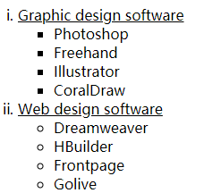

(Give screenshots of the source code and the result.)

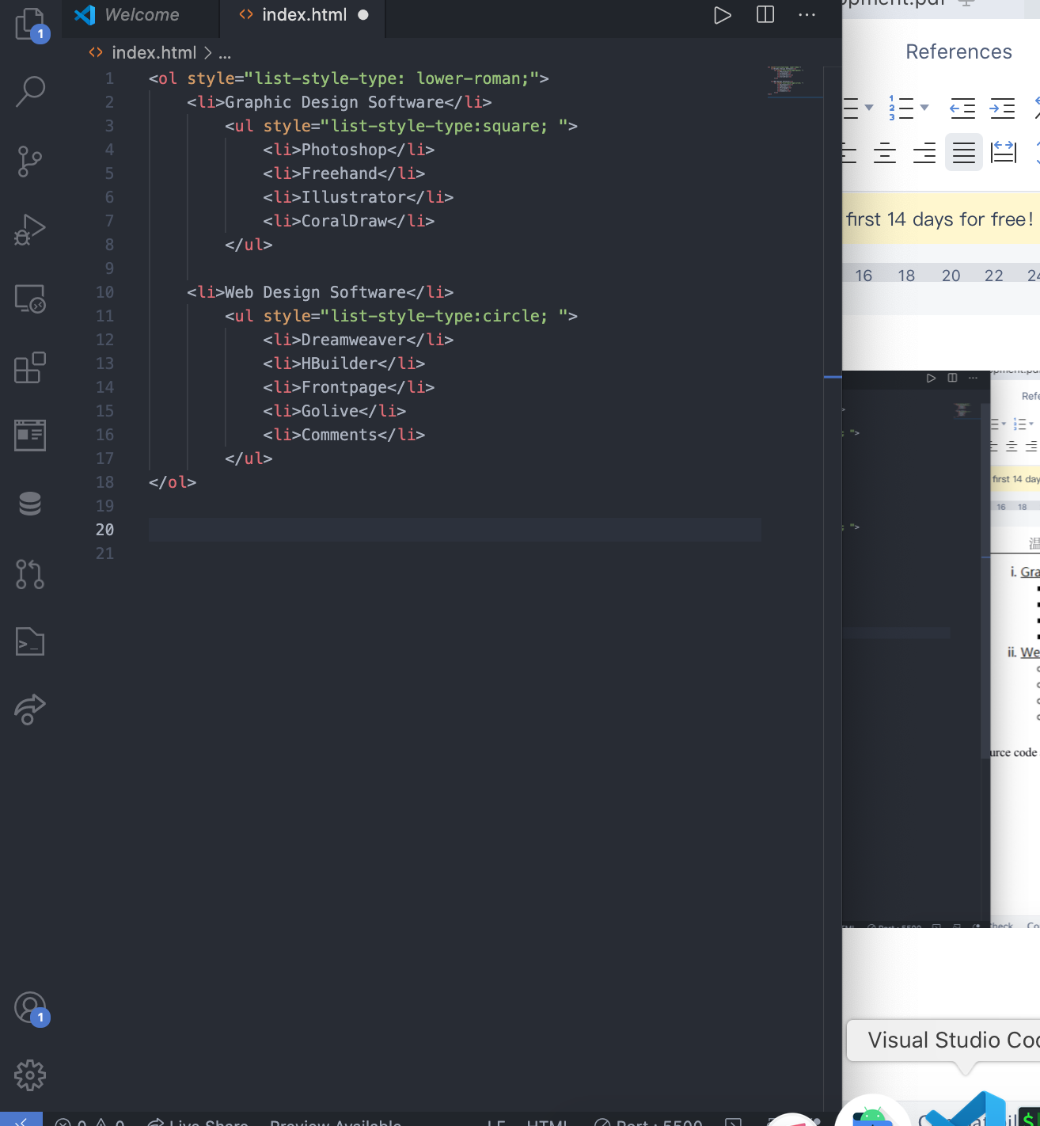

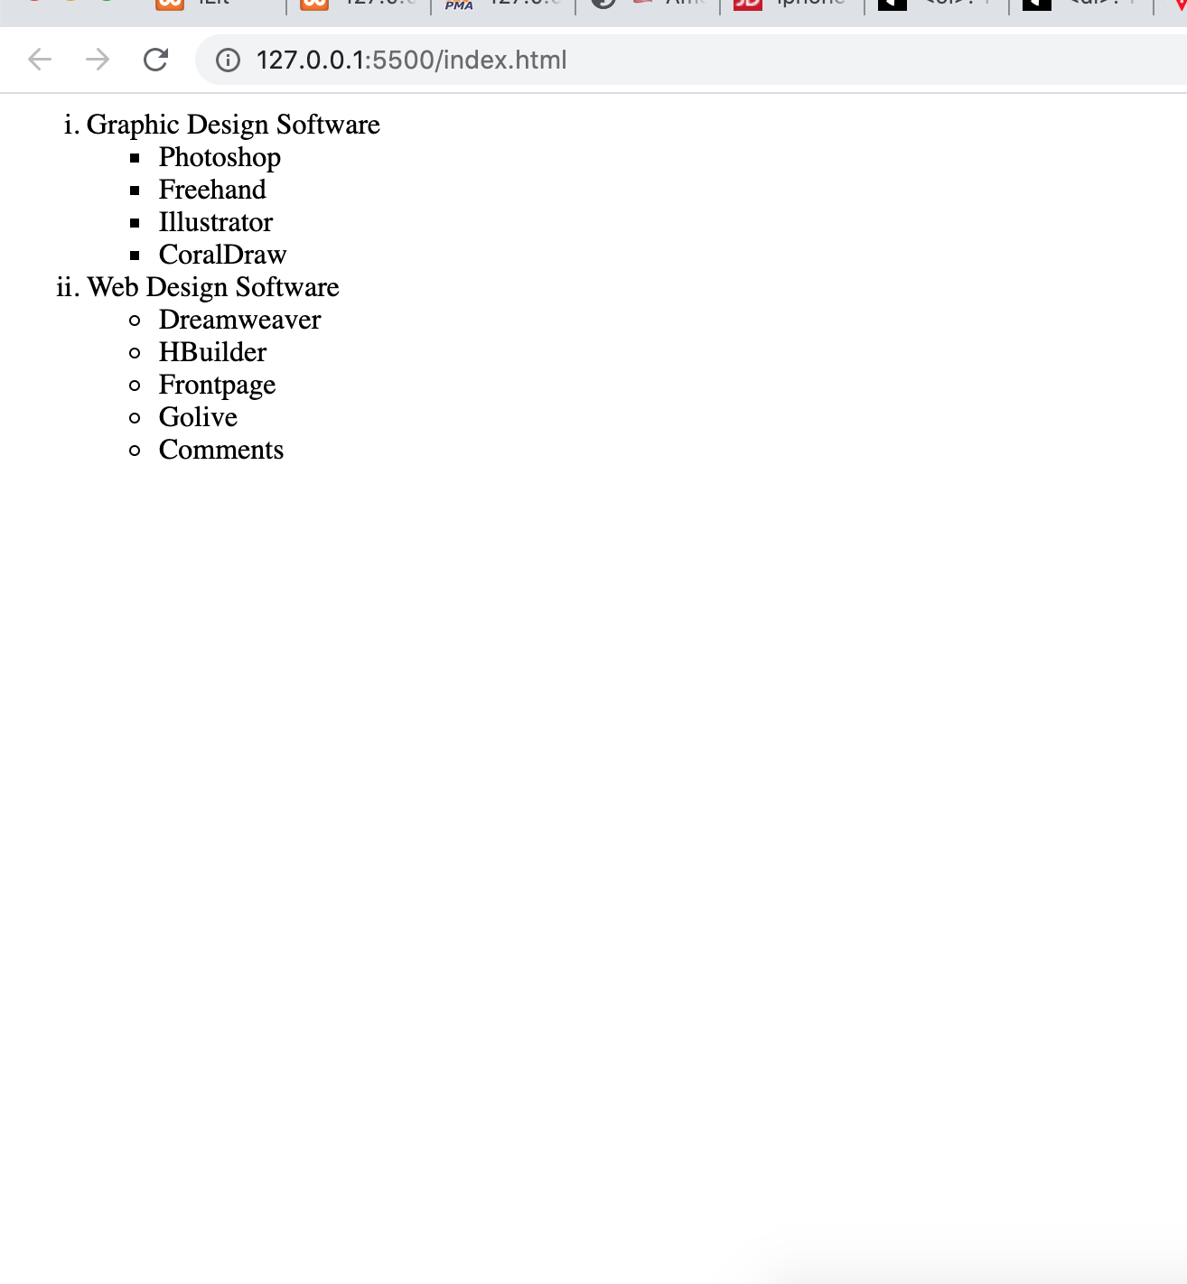

2. What is the meaning of h1+p?

It describes sibling relationship. This targets only the paragraph that immediately follows a level-one headline. All other paragraphs will be ignored.

3. Lists out the detailed steps to style a paragraph using class
(Give an example for it and have screenshots of the source code and the result.)

<style>
p{
color:gray;
}
p.p1{
Color:green;
}
.p2{
Color:green;

}
</style>

<p class="p1" >paragraph 1</p>
<p class="p2" >paragraph 2</p>

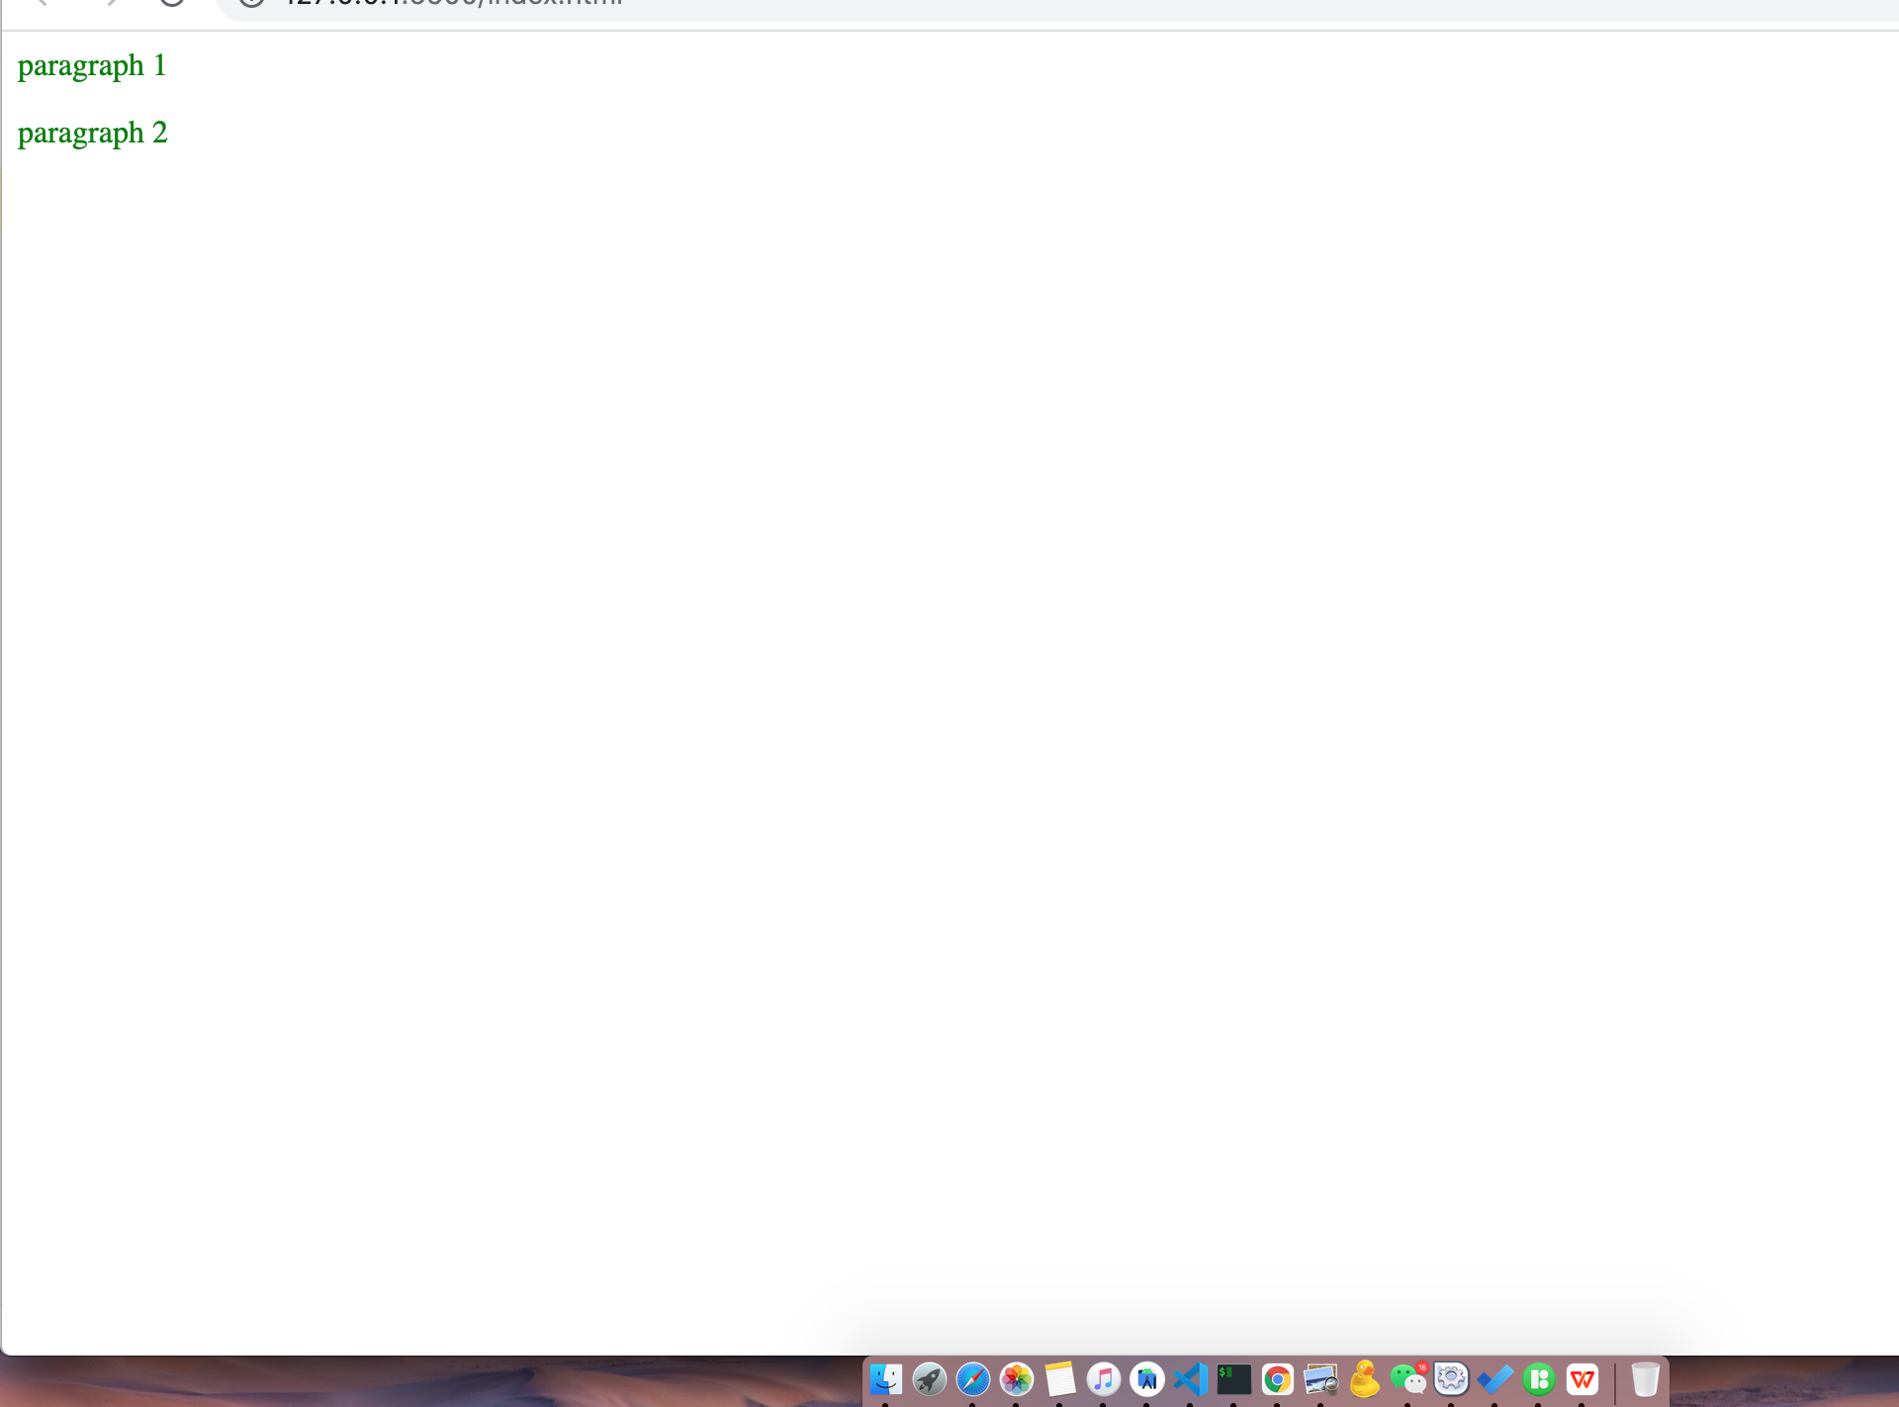

4. What is an object, and describe the characteristics of an object
(Give an example for it and have screenshots of the source code and the result.)

Describe the characteristics of an object

Properties: this associates name (or key) and a value

Methods: These are functions, like checkNavigator();

Events: Stimuli the object responds to, such as “click”, ”scroll”

In javascript An object is a collection of properties, and a property is an association between a name (or key) and a value. A property's value can be a function, in which case the property is known as a method.

Everything is an obect!!!!!

Variables, ! functions, arrays all objects but you can create custom objects

Like so;

<script>

var classRoom= new Object();
classRoom.classTeacher = "Tom";
classRoom.totalStudents = 5;
alert("the class teachers name is " + classRoom.classTeacher+" and the students are "+classRoom.totalStudents+" in number" );

</script>

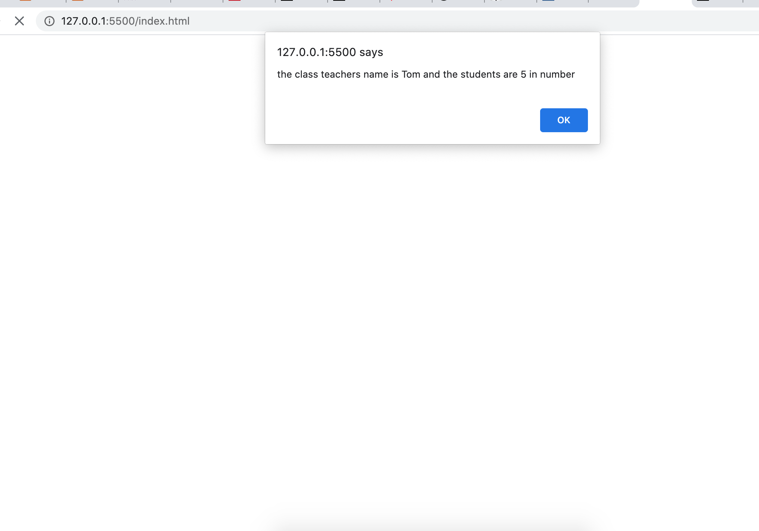

- Describe the features of variable.

While naming javascript variables we need to consider the below

variable names can contain letters, digits, underscores, and dollar signs.
variable names must begin with a letter
variable names can also begin with $ and _ (but we will not use it in this tutorial)
variable names are case sensitive (y and Y are different variables)
to declare a variable we do like so;
We can declare a variable using var, let, or const
var varName;
Let varName;
But for const we have to assign the value at definition
Like so;
Const maga=”this_value”;
Assignment
varName=”this_value”;
varName=”that_value”;

//----------Adding more------
var pi = 3.14;
var person = "winner";
var answer = 'i am student!';

6. How many different levels of headings does HTML support? What are their tags?
(Give an example for it and have screenshots of the source code and the result.)

